# ATS OPTIMIZED RESUME ANALYZER

## Project by: Harsha Hemanth Gurram

### Github Link: https://github.com/Harsha-Hemanth/ATS-Optimized-Resume-Analyzer

## Table of Contents:

|  |  |  |
| --- | --- | --- |
| S.No | Content | Page Number |
| 1 | Introduction | 2 |
| 2 | Features and Functionality | 2 |
| 3 | Tools and Technology Required | 2 |
| 4 | Technical Architecture | 3 |
| 5 | How it Works | 3 |
| 6 | Usage | 3 |
| 7 | Future Enhancement | 5 |
| 8 | Conclusion | 5 |

## Introduction

This AI-powered Resume Analyzer helps users optimize their resumes for Applicant Tracking Systems (ATS) by providing personalized feedback and insights using Google Generative AI. Simply upload your resume, and the application will analyze its content and suggest improvements to boost its ATS performance.

## Features and Functionality

* AI-Powered Insights: Get feedback on your resume content using Google Generative AI.
* PDF Upload: Upload your resume in PDF format for analysis.
* Keyword Matching: Automatically checks your resume for important keywords related to the job role.
* ATS Optimization Tips: Provides suggestions to make your resume more ATS-friendly.
* Skill Scoring: Analyzes the skills section and offers scoring based on relevance.
* Interactive UI: Easy-to-use interface built using Streamlit.
* Privacy Focused: Your data is not stored, ensuring privacy and security.

## Tools and Technology Required

Make sure you have the following installed:

* Python 3.11 or higher: Programming language.
* Streamlit: Framework for building interactive web apps
* Google Generative AI: For AI-powered resume analysis
* PyPDF2: To read and extract text from PDF files
* python-dotenv: To load environment variables securely

## Technical Architecture

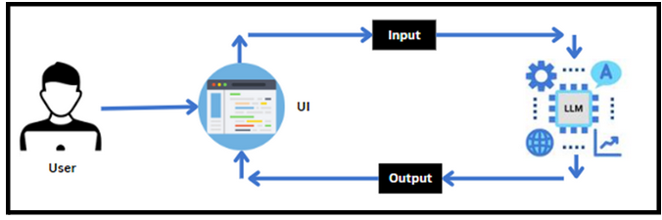

## How it Works

1. Upload PDF: Users upload their resume as a PDF file.
2. Text Extraction: The PyPDF2 library extracts the text from the PDF.
3. AI Analysis: The extracted text is analyzed using Google Generative AI for keyword relevance and ATS optimization.
4. Feedback: The system provides actionable feedback for improving the resume.

## 6.Usage

streamlit run app.py

1. Run the Streamlit application:
2. Open your browser and goto <https://localhost/8051.>

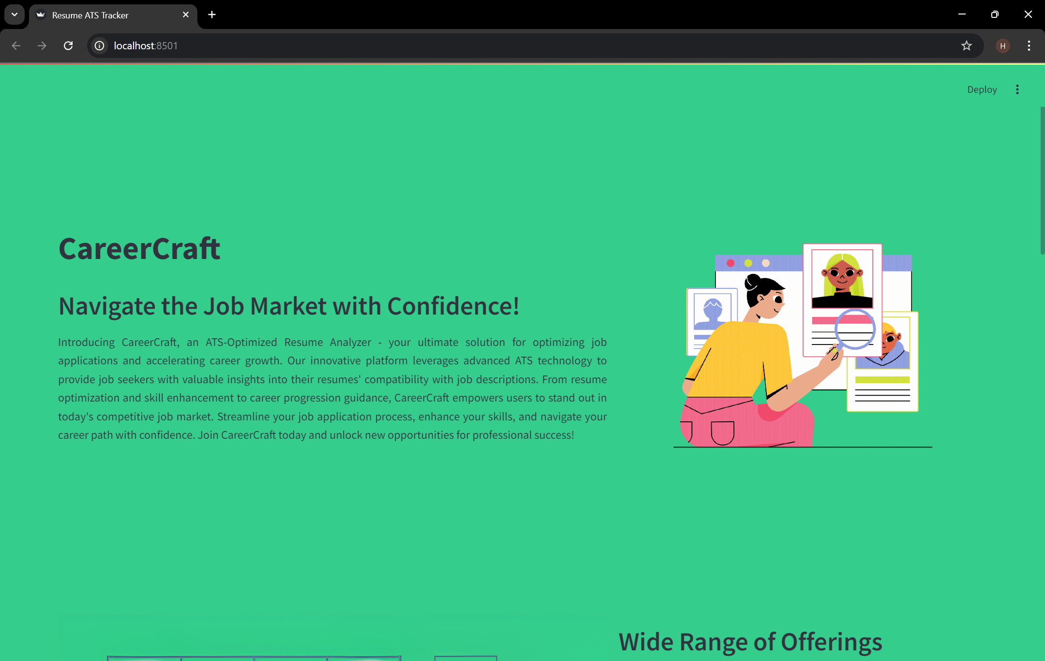

1. Upload your resume in PDF format and let the analyzer do its magic. It will display the following information:

* ATS Score
* Keyword Analysis
* Suggestions for Improvement

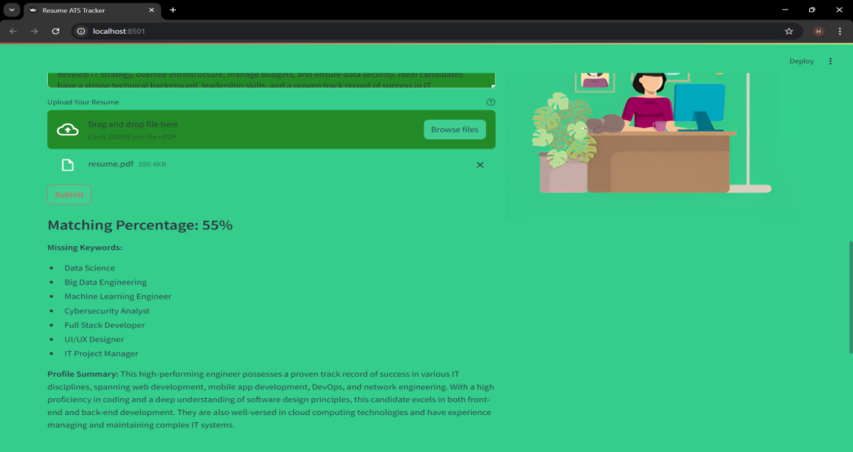

## 7. Future Enhancements

* Add support for multiple file types (e.g., .docx).
* Include job description matching for targeted resume improvements.
* Integrate more AI models for deeper analysis.

## Conclusion

In conclusion, the ATS-Optimized Resume Analyzer is an AI-driven tool that helps job seekers enhance their resumes for better ATS compatibility. It offers valuable insights, keyword analysis, and personalized suggestions using Google Generative AI, ensuring users optimize their resumes effectively. With its easy-to-use Streamlit interface, it provides a seamless experience for resume analysis. Future enhancements aim to add multi-format support and job description matching for a more comprehensive analysis.